Q-6-2

1) The article "Freedom of What?" (Associated Press, February 1, 2005) described a study in which high school students and high school teachers were asked to agree or disagree with the following statement: "Students should be allowed to report controversial issues in their student newspapers without the approval of school authorities." Researchers hypothesized that the long-run proportion of high school teachers who would agree with the statement would differ from the long-run proportion of high school students who would agree. Two random samples – 8,000 high school teachers and 10,000 high school students – were selected from high schools in the U.S. From the survey, 39% of the teachers and 58% of the students agreed with the statement.
State the null and alternative hypotheses.
a. $H_{0}:π_{\text{student}}$ - $π_{\text{teacher}}$ = 0 versus $H_{A}:π_{\text{student}}$ - $π_{\text{teacher}}$ < 0
b. $H_{0}:π_{\text{student}}$ - $π_{\text{teacher}}$ = 0 versus $H_{A}:π_{\text{student}}$ - $π_{\text{teacher}}$ > 0
c. $H_{0}:π_{\text{student}}$ - $π_{\text{teacher}}$ = 0 versus $H_{A}:π_{\text{student}}$ - $π_{\text{teacher}}$ ≠ 0
d. $H_{0}:π_{\text{student}}$ - $π_{\text{teacher}}$ = 0 versus $H_{A}:π_{\text{student}}$ - $π_{\text{teacher}}$ = 0

2) A Gallup poll headline from April 25, 2013, reads "In U.S., Women Veterans Rate Lives Better Than Men". In a random sample of 900 female veterans interviewed, 459 rated their lives as "thriving." Only 693 male veterans rated their lives as "thriving" in a random sample of size 1,650.
What is the null hypothesis if researchers are interested in determining if the long-run proportion who would rate their lives as thriving differs between women and men?
a. There is an association between sex and whether a person would rate their life as thriving.
b. There is no association between sex and whether a person would rate their life as thriving.
c. There is an association between whether a person is a veteran and whether a person would rate their life as thriving.
d. There is no association between whether a person is a veteran and whether a person would rate their life as thriving.

3) The article "Freedom of What?" (Associated Press, February 1, 2005) described a study in which high school students and high school teachers were asked to agree or disagree with the following statement: "Students should be allowed to report controversial issues in their student newspapers without the approval of school authorities." Researchers hypothesized that the long-run proportion of high school teachers who would agree with the statement would differ from the long-run proportion of high school students who would agree. Two random samples – 8,000 high school teachers and 10,000 high school students – were selected from high schools in the U.S. From the survey, 39% of the teachers and 58% of the students agreed with the statement.
What is the value of the statistic and its appropriate notation?
a. $̂p$ = 0.58
b. $̂p$ = 0.39
c. $̂p_{\text{student}}$ - $̂p_{\text{teacher}}$ = 0.19
d. $π_{\text{student}}$ - $π_{\text{teacher}}$ = 0.19

4) The article "Freedom of What?" (Associated Press, February 1, 2005) described a study in which high school students and high school teachers were asked to agree or disagree with the following statement: "Students should be allowed to report controversial issues in their student newspapers without the approval of school authorities." Researchers hypothesized that the long-run proportion of high school teachers who would agree with the statement would differ from the long-run proportion of high school students who would agree. Two random samples – 8,000 high school teachers and 10,000 high school students – were selected from high schools in the U.S. From the survey, 39% of the teachers and 58% of the students agreed with the statement.
Describe how cards could be used to simulate a single sample statistic in the null distribution.
a. Take 8,000 red cards and 10,000 blue cards. Shuffle the cards together, then deal the cards into two piles – one of size 8,000 and one of size 10,000. Compute the difference in the proportion of red cards between the two piles.
b. Take 8,000 red cards and 10,000 blue cards. Shuffle the cards together, then deal the cards into two piles – one of size 3,120 and one of size 5,800. Compute the difference in the proportion of red cards between the two piles.
c. Take 8,920 red cards and 9,080 blue cards. Shuffle the cards together, then deal the cards into two piles – one of size 8,000 and one of size 10,000. Compute the difference in the proportion of red cards between the two piles.
d. Take 8,920 red cards and 9,080 blue cards. Shuffle the cards together, then deal the cards into two piles – one of size 4,640 and one of size 3,900. Compute the difference in the proportion of red cards between the two piles.

5) The article "Freedom of What?" (Associated Press, February 1, 2005) described a study in which high school students and high school teachers were asked to agree or disagree with the following statement: "Students should be allowed to report controversial issues in their student newspapers without the approval of school authorities." Researchers hypothesized that the long-run proportion of high school teachers who would agree with the statement would differ from the long-run proportion of high school students who would agree. Two random samples – 8,000 high school teachers and 10,000 high school students – were selected from high schools in the U.S. From the survey, 39% of the teachers and 58% of the students agreed with the statement.
A simulated null distribution of 1,000 differences in proportions created by using the Two Proportion applet is shown below.
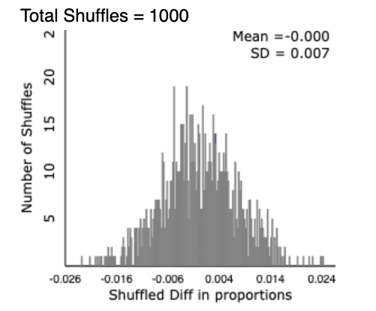
What is the strength of evidence against observed study results happening by chance alone?
a. Very strong
b. Moderate
c. Weak
d. We cannot determine the strength of evidence from this plot.

6) To investigate biases against women in personnel decisions, psychologists performed a randomized experiment on 50 male bank supervisors attending a management institute who volunteered for the study. The supervisors were asked to make a decision on whether to promote a hypothetical applicant based on a personnel file. 26 the application files described a female candidate; for the others the file described a male. The files were identical in all other respects. Results on the promotion decisions for the two groups are shown below.
 | Applicant’s Sex
Promoted? | Male | Female | Total
Yes | 21 | 14 | 35
No | 3 | 12 | 15
Total | 24 | 26 | 50
The standardized statistic for this study is 2.59. How would this value be interpreted?
a. The sample proportion of men promoted is 2.59 standard deviations above the sample proportion of women promoted.
b. The sample difference in proportion promoted between men and women (men – women) is 2.59 standard deviations above zero.
c. On average, sample differences in proportion promoted between men and women (men – women) are 2.59 standard deviations from zero.
d. There is a 2.59% chance of seeing a sample difference in proportion promoted between men and women (men – women) of the one observed or greater.

7) The article "Freedom of What?" (Associated Press, February 1, 2005) described a study in which high school students and high school teachers were asked to agree or disagree with the following statement: "Students should be allowed to report controversial issues in their student newspapers without the approval of school authorities." Researchers hypothesized that the long-run proportion of high school teachers who would agree with the statement would differ from the long-run proportion of high school students who would agree. Two random samples – 8,000 high school teachers and 10,000 high school students – were selected from high schools in the U.S. From the survey, 39% of the teachers and 58% of the students agreed with the statement.
A simulated null distribution of 1,000 differences in proportions created by using the Two Proportion applet is shown below.
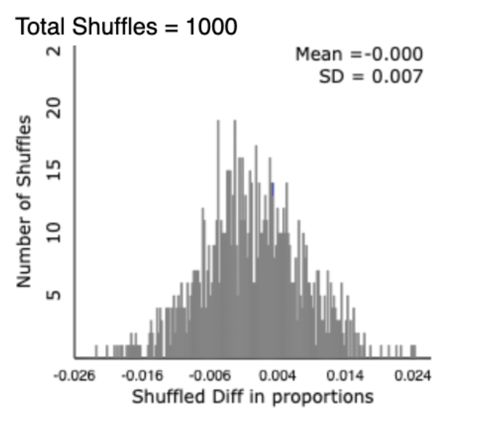
Use the 2SD method to find a 95% confidence interval for the difference in long-run proportion who would agree with the statement between Students and Teachers (Students – Teachers).
a. ( -0.014, 0.014)
b. (0.176 , 0.204)
c. ( 0.183, 0.907)
d. ( 0.159 , 0.239)

8) To investigate biases against women in personnel decisions, psychologists performed a randomized experiment on 50 male bank supervisors attending a management institute who volunteered for the study. The supervisors were asked to make a decision on whether to promote a hypothetical applicant based on a personnel file. 26 the application files described a female candidate; for the others the file described a male. The files were identical in all other respects. Results on the promotion decisions for the two groups are shown below.
 | Applicant’s Sex
Promoted? | Male | Female | Total
Yes | 21 | 14 | 35
No | 3 | 12 | 15
Total | 24 | 26 | 50
The standardized statistic for this study is 2.59, and the p-value is 0.009. State a conclusion of the test in context of the problem.
a. Significant evidence does not exist that the probability an applicant is promoted is higher for women than for men.
b. Significant evidence does not exist that the probability an applicant is promoted is higher for men than for women.
c. Significant evidence exists that the probability an applicant is promoted is higher for women than for men.
d. Significant evidence exists that the probability an applicant is promoted is higher for men than for women.

